DOCKER CHALLENGE
Task 1: Build a customized Python Docker image
Perform these steps on your Ubuntu Docker server.
Step 1: Check Docker and Git
docker --version
git --version
docker ps
If all commands work, continue.
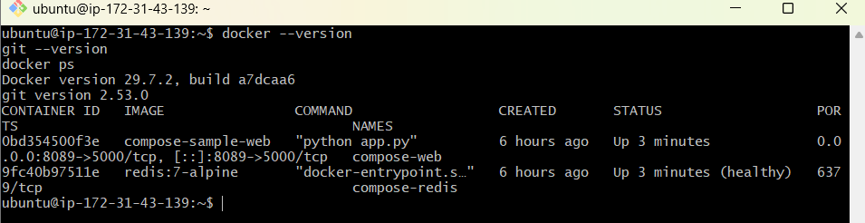
Step 2: Clone the Python application
cd ~
git clone https://github.com/betawins/Python-app.git
cd Python-app
ls -la
You should see:
app.py
Dockerfile
Jenkinsfile
requirements.txt
templates
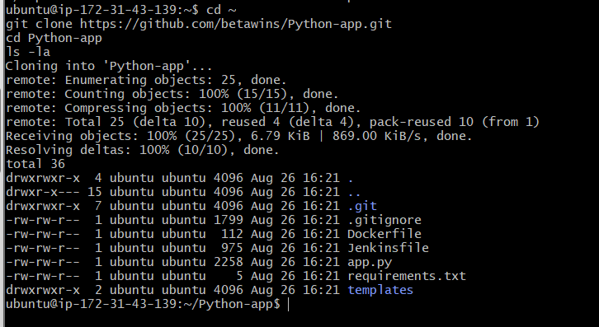
Step 3: Replace the old Dockerfile
Open the Dockerfile:
nano Dockerfile
Delete the existing content and add:
FROM python:3.12-slim

WORKDIR /app

COPY requirements.txt .

RUN pip install --no-cache-dir -r requirements.txt

COPY . .

EXPOSE 8080

CMD ["python", "app.py"]
Save it:
Ctrl+O
Enter
Ctrl+X
Dockerfile explanation
Instruction | Purpose
FROM python:3.12-slim | Uses a small Python base image
WORKDIR /app | Sets /app as the working directory
COPY requirements.txt . | Copies the dependency file
RUN pip install... | Installs Flask
COPY . . | Copies the application source code
EXPOSE 8080 | Documents the application port
CMD | Starts the Python application
Step 4: Build the Docker image
Use your Docker Hub username:
docker build -t venudocker8899/python-app:v1 .
Verify:
docker images
Expected image:
venudocker8899/python-app v1
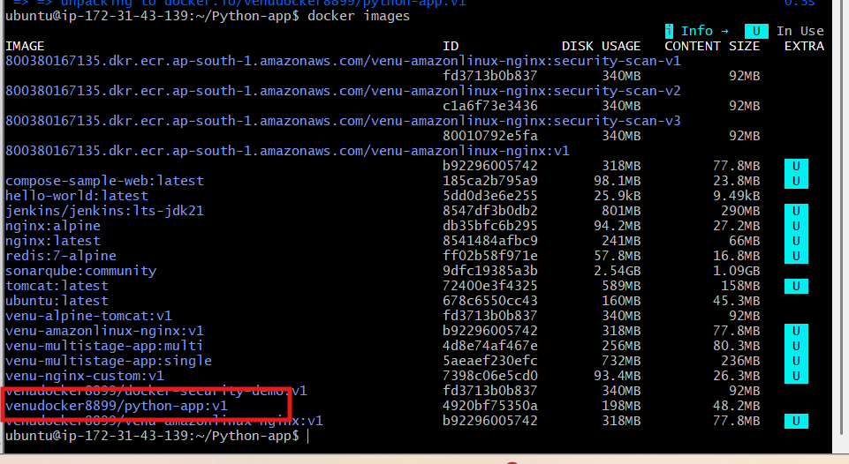
Step 5: Run the container
docker run -d \
--name python-app-container \
-p 8080:8080 \
venudocker8899/python-app:v1
Check its status:
docker ps
Check logs:
docker logs python-app-container
Test locally:
curl http://localhost:8080
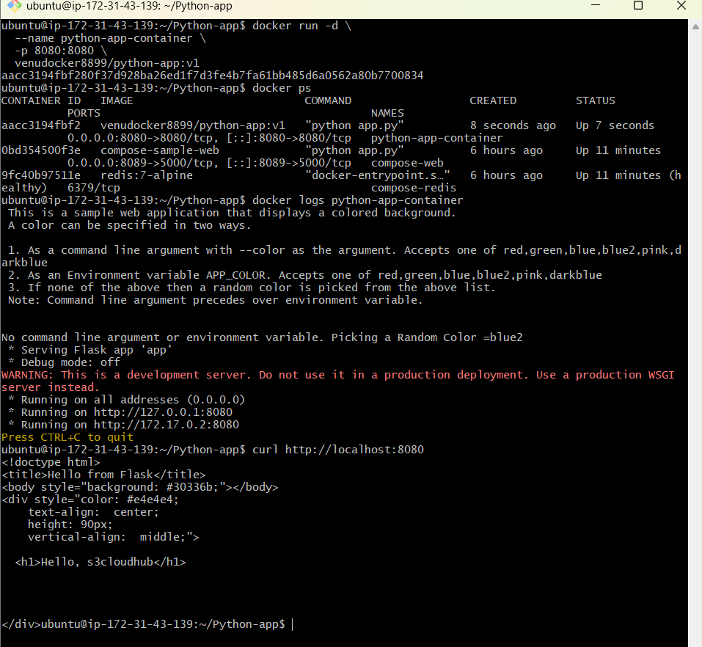
You can also open:
http://EC2-PUBLIC-IP:8080
Make sure the EC2 security group allows:
Type | Port | Source
Custom TCP | 8080 | My IP or 0.0.0.0/0 temporarily
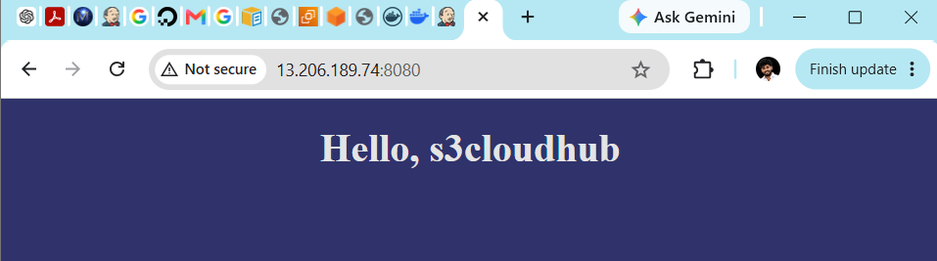
Step 6: Verify the application
Run:
curl -I http://localhost:8080
Expected result:
HTTP/1.1 200 OK
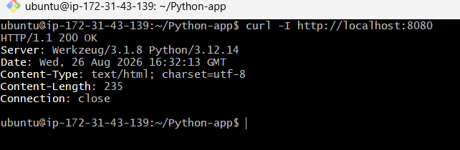
If port 8080 is already occupied, use port 8085:
docker rm -f python-app-container

docker run -d \
--name python-app-container \
-p 8085:8080 \
venudocker8899/python-app:v1
Then test:
curl http://localhost:8085
Once this container works, the next task is pushing venudocker8899/python-app:v1 to Docker Hub.
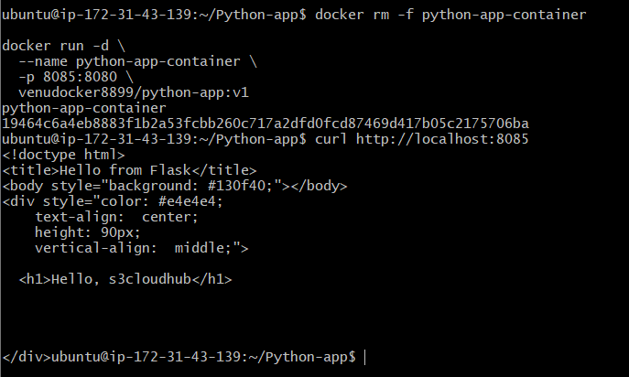

Task 2: Push the image to Docker Hub
Step 1: Create the Docker Hub repository
Sign in to Docker Hub and create:
Repository name: python-app
Visibility: Public
The complete repository name will be:
venudocker8899/python-app
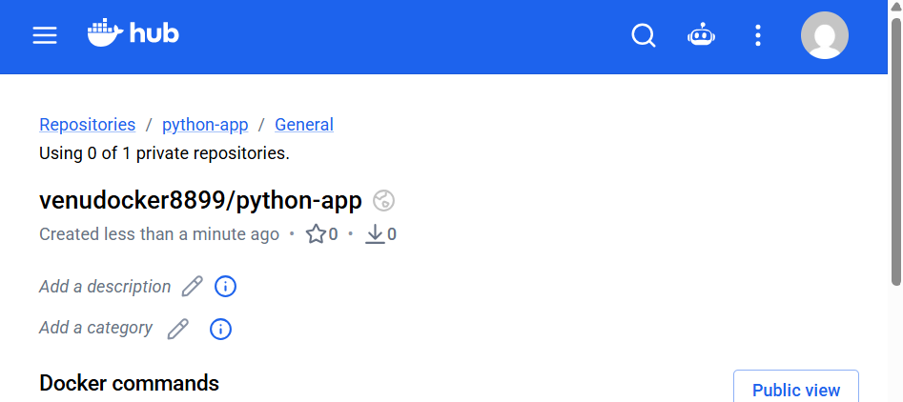
Step 2: Log in from the EC2 instance
docker login -u venudocker8899
When prompted for the password, paste your Docker Hub personal access token, not your Docker Hub password.
Important: characters will not appear while pasting. This is normal.
Expected output:
Login Succeeded
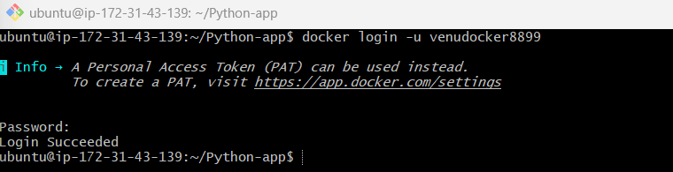
Step 3: Confirm the image tag
docker images venudocker8899/python-app
You should see:
REPOSITORY TAG
venudocker8899/python-app v1
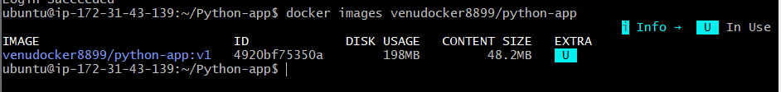
Step 4: Push the image
docker push venudocker8899/python-app:v1
Expected final lines:
v1: digest: sha256:...
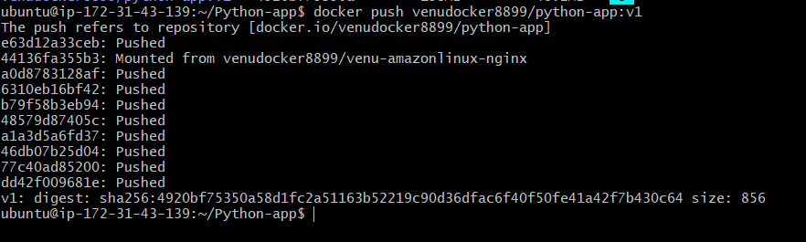
Step 5: Verify on Docker Hub
Open your Docker Hub repository and check that the following tag is displayed:
v1
Your application container can remain running. You do not need to stop it before pushing the image.
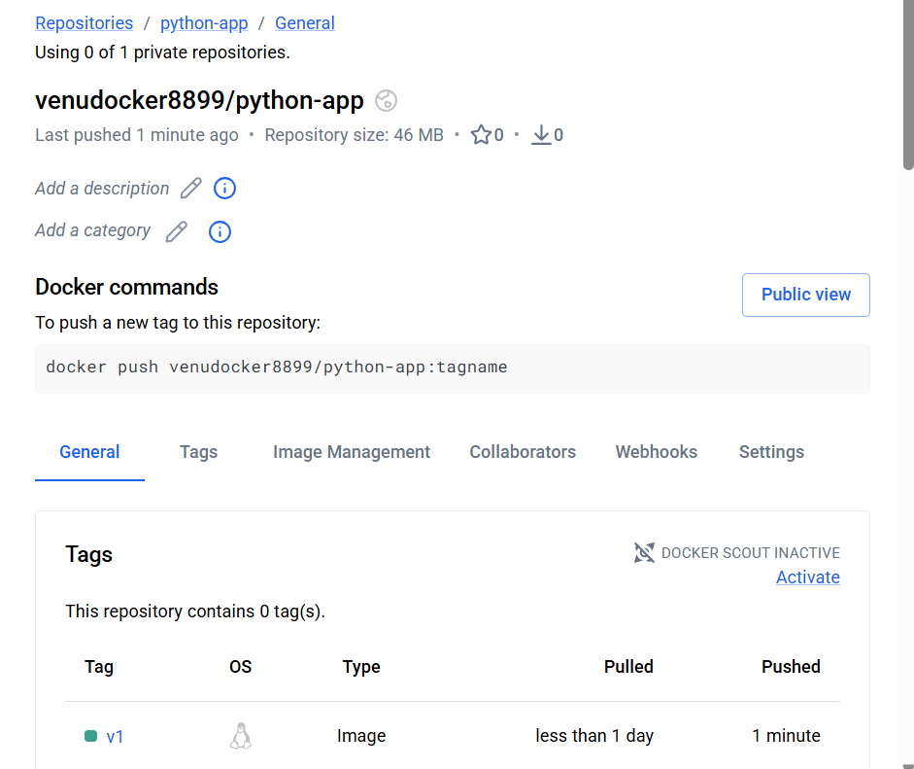
Task 3: Push the same image to Amazon ECR
First, verify AWS CLI and AWS authentication:
aws --version
Then:
aws sts get-caller-identity
Expected output resembles:
{
"UserId": "...",
"Account": "800380167135",
"Arn": "..."
}
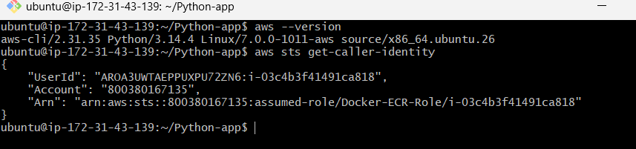
If both commands succeed, create the ECR repository:
aws ecr create-repository \
--repository-name python-app \
--region ap-south-1
If it says the repository already exists, that is okay.
Next, log Docker in to ECR:
aws ecr get-login-password --region ap-south-1 | \
docker login \
--username AWS \
--password-stdin \
800380167135.dkr.ecr.ap-south-1.amazonaws.com
Expected:
Login Succeeded
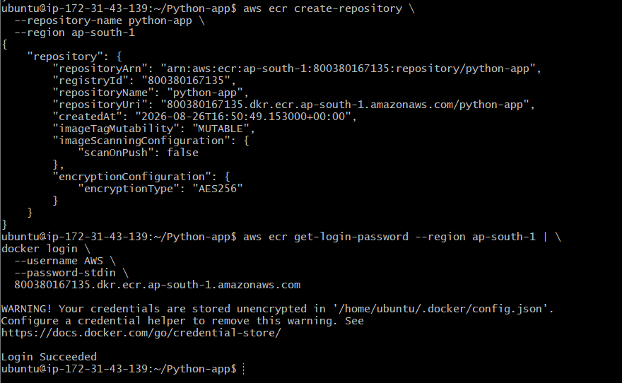
For now, run these first two commands and send me the output:
aws --version
aws sts get-caller-identity
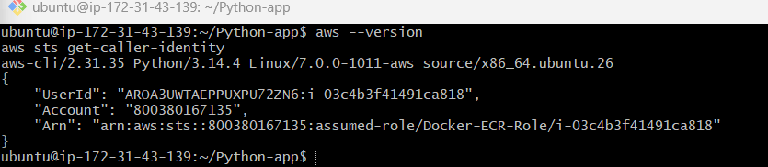
AWS CLI is configured through the EC2 IAM role:
Role: Docker-ECR-Role
Account: 800380167135
Region: ap-south-1
Step 1: Create the ECR repository
Run:
aws ecr create-repository \
--repository-name python-app \
--region ap-south-1
If successful, the repository URI will be:
800380167135.dkr.ecr.ap-south-1.amazonaws.com/python-app
If you receive:
RepositoryAlreadyExistsException
that is okay—continue.
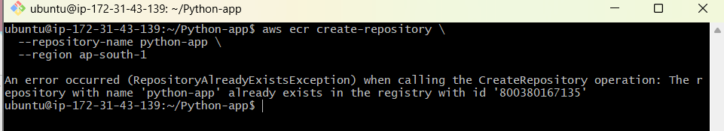
Step 2: Log in to Amazon ECR
aws ecr get-login-password --region ap-south-1 | \
docker login \
--username AWS \
--password-stdin \
800380167135.dkr.ecr.ap-south-1.amazonaws.com
Expected:
Login Succeeded
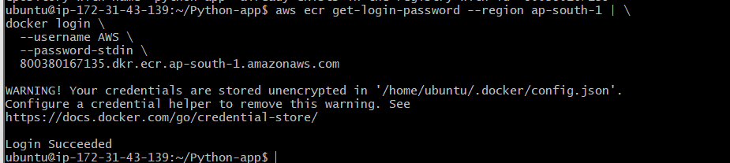
Step 3: Tag the existing image for ECR
docker tag \
venudocker8899/python-app:v1 \
800380167135.dkr.ecr.ap-south-1.amazonaws.com/python-app:v1
Verify both tags:
docker images | grep python-app
Step 4: Push the image to ECR
docker push \
800380167135.dkr.ecr.ap-south-1.amazonaws.com/python-app:v1
Expected final output:
v1: digest: sha256:...
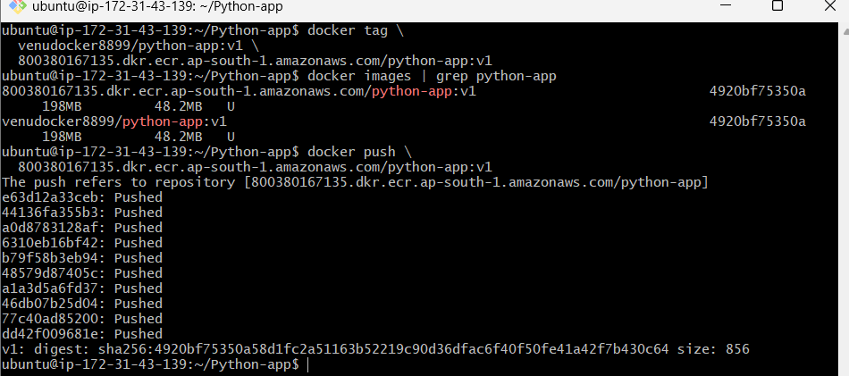

Task 4: Provision Jenkins EC2 using Terraform
We will run Terraform from your existing Docker-Practice-Server. Terraform will create a separate EC2 instance named:
Terraform-Jenkins-Server
The new instance will contain:
- Ubuntu 24.04
- Java 21
- Jenkins
- Docker
- Git
- Jenkins port 8080
Step 1: Install Terraform
Run on Docker-Practice-Server:
sudo apt update
sudo apt install -y wget gpg
Add HashiCorp’s signing key:
wget -O - https://apt.releases.hashicorp.com/gpg | \
sudo gpg --dearmor \
-o /usr/share/keyrings/hashicorp-archive-keyring.gpg
Add the repository:
echo "deb [arch=$(dpkg --print-architecture) signed-by=/usr/share/keyrings/hashicorp-archive-keyring.gpg] https://apt.releases.hashicorp.com $(grep -oP '(?<=UBUNTU_CODENAME=).*' /etc/os-release) main" | \
sudo tee /etc/apt/sources.list.d/hashicorp.list
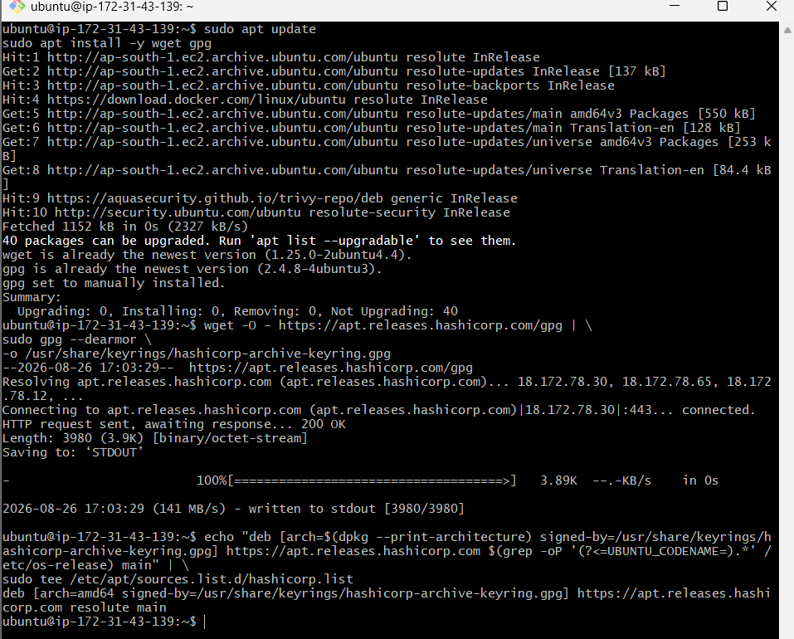
Install Terraform:
sudo apt update
sudo apt install -y terraform
Verify:
terraform –version
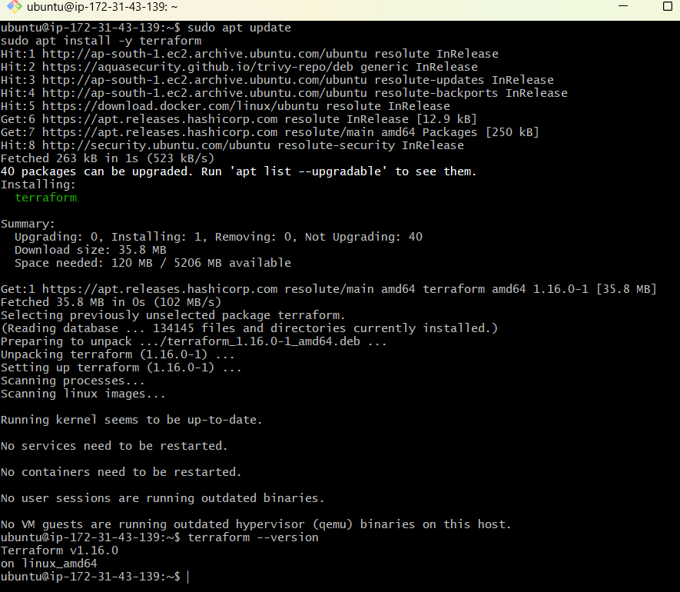
Step 2: Check EC2 permission
Your current EC2 uses this IAM role:
Docker-ECR-Role
Test whether it can access EC2:
aws ec2 describe-vpcs \
--region ap-south-1 \
--query 'Vpcs[*].[VpcId,IsDefault]' \
--output table
If the command returns VPC details, continue.
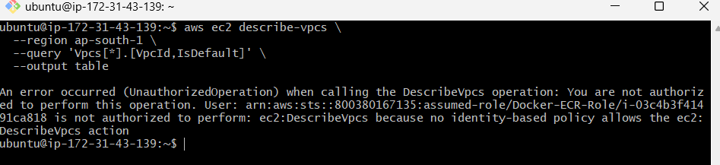
If you get UnauthorizedOperation, go to:
AWS Console
→ IAM
→ Roles
→ Docker-ECR-Role
→ Add permissions
→ Attach policies
For this lab, attach:
AmazonEC2FullAccess
This is broad access suitable only for the practice lab. A production setup should use a restricted custom policy.
Run the describe-vpcs command again after attaching it.
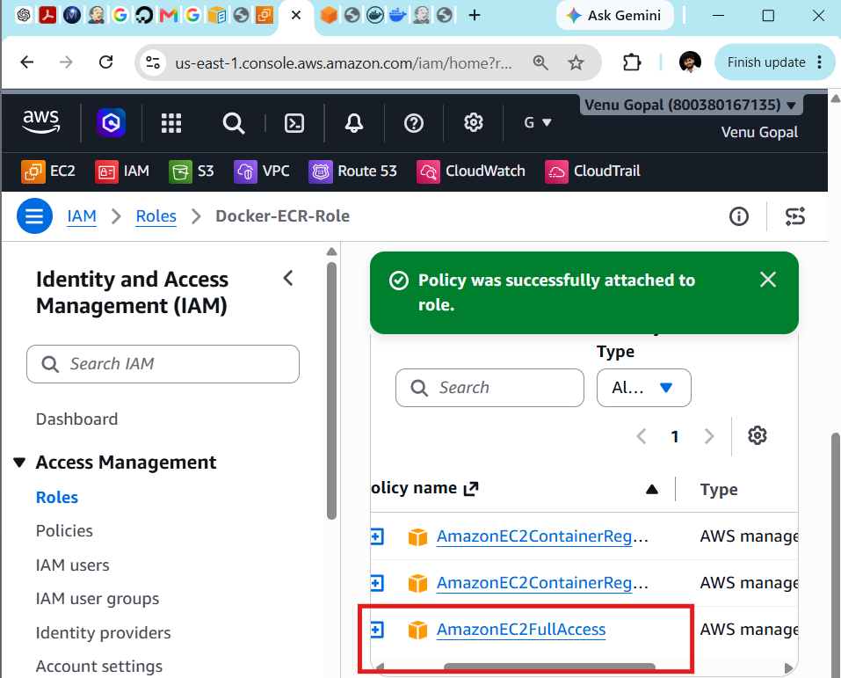
Step 3: Find your EC2 key-pair name
aws ec2 describe-key-pairs \
--region ap-south-1 \
--query 'KeyPairs[*].KeyName' \
--output table
You may see:
docker-practice-key
Use the exact key-pair name displayed by this command.
Step 4: Create the Terraform directory
cd ~
mkdir -p terraform-jenkins
cd terraform-jenkins
Check:
pwd
Expected:
/home/ubuntu/terraform-jenkins
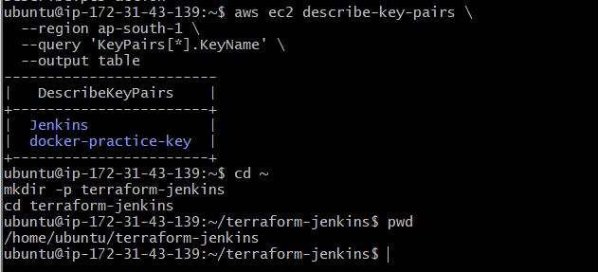
Step 5: Create main.tf
nano main.tf
Add:
terraform {
required_version = ">= 1.5.0"

required_providers {
aws = {
source = "hashicorp/aws"
version = "~> 6.0"
}
}
}

provider "aws" {
region = "ap-south-1"
}

# Find the default VPC
data "aws_vpc" "default" {
default = true
}

# Find subnets belonging to the default VPC
data "aws_subnets" "default" {
filter {
name = "vpc-id"
values = [data.aws_vpc.default.id]
}
}

# Find the latest Ubuntu 24.04 AMI
data "aws_ami" "ubuntu" {
most_recent = true
owners = ["099720109477"]

filter {
name = "name"
values = ["ubuntu/images/hvm-ssd-gp3/ubuntu-noble-24.04-amd64-server-*"]
}

filter {
name = "virtualization-type"
values = ["hvm"]
}

filter {
name = "architecture"
values = ["x86_64"]
}
}

# Jenkins security group
resource "aws_security_group" "jenkins_sg" {
name = "terraform-jenkins-sg"
description = "Allow SSH and Jenkins"
vpc_id = data.aws_vpc.default.id

ingress {
description = "SSH access"
from_port = 22
to_port = 22
protocol = "tcp"
cidr_blocks = ["0.0.0.0/0"]
}

ingress {
description = "Jenkins web access"
from_port = 8080
to_port = 8080
protocol = "tcp"
cidr_blocks = ["0.0.0.0/0"]
}

egress {
description = "Allow outbound traffic"
from_port = 0
to_port = 0
protocol = "-1"
cidr_blocks = ["0.0.0.0/0"]
}

tags = {
Name = "Terraform-Jenkins-SG"
}
}

# Jenkins EC2 instance
resource "aws_instance" "jenkins" {
ami = data.aws_ami.ubuntu.id
instance_type = var.instance_type
key_name = var.key_name
subnet_id = data.aws_subnets.default.ids[0]
vpc_security_group_ids = [aws_security_group.jenkins_sg.id]
associate_public_ip_address = true

root_block_device {
volume_size = 20
volume_type = "gp3"
}

user_data = <<-EOF
#!/bin/bash
set -e

apt-get update
apt-get install -y fontconfig openjdk-21-jre wget git docker.io

mkdir -p /etc/apt/keyrings

wget -O /etc/apt/keyrings/jenkins-keyring.asc \
https://pkg.jenkins.io/debian-stable/jenkins.io-2026.key

echo "deb [signed-by=/etc/apt/keyrings/jenkins-keyring.asc] https://pkg.jenkins.io/debian-stable binary/" \
> /etc/apt/sources.list.d/jenkins.list

apt-get update
apt-get install -y jenkins

systemctl enable --now docker
systemctl enable --now jenkins

usermod -aG docker jenkins
systemctl restart jenkins
EOF

tags = {
Name = "Terraform-Jenkins-Server"
Project = "Docker-Jenkins-Lab"
}
}
Save:
Ctrl+O
Enter
Ctrl+X
The Java and Jenkins installation commands follow the current official Jenkins Ubuntu instructions.
Step 6: Create variables.tf
nano variables.tf
Add:
variable "key_name" {
description = "Existing EC2 key-pair name"
type = string
}

variable "instance_type" {
description = "Jenkins EC2 instance type"
type = string
default = "t3.small"
}
Save and exit.
Step 7: Create terraform.tfvars
nano terraform.tfvars
Add your existing key-pair name:
key_name = "docker-practice-key"
instance_type = "t3.small"
Replace docker-practice-key if the key-pair command showed a different name.
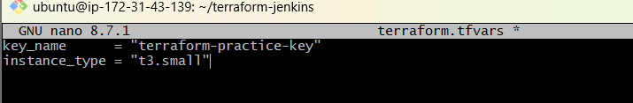
Save and exit.
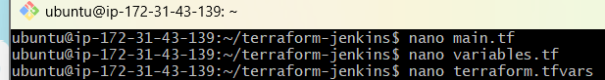
Step 8: Create outputs.tf
nano outputs.tf
Add:
output "jenkins_instance_id" {
value = aws_instance.jenkins.id
}

output "jenkins_public_ip" {
value = aws_instance.jenkins.public_ip
}

output "jenkins_url" {
value = "http://${aws_instance.jenkins.public_ip}:8080"
}

output "ssh_command" {
value = "ssh -i <your-key-file>.pem ubuntu@${aws_instance.jenkins.public_ip}"
}
Save and exit.
Step 9: Format and validate
terraform fmt
Initialize Terraform:
terraform init
Validate:
terraform validate
Expected:
Success! The configuration is valid.
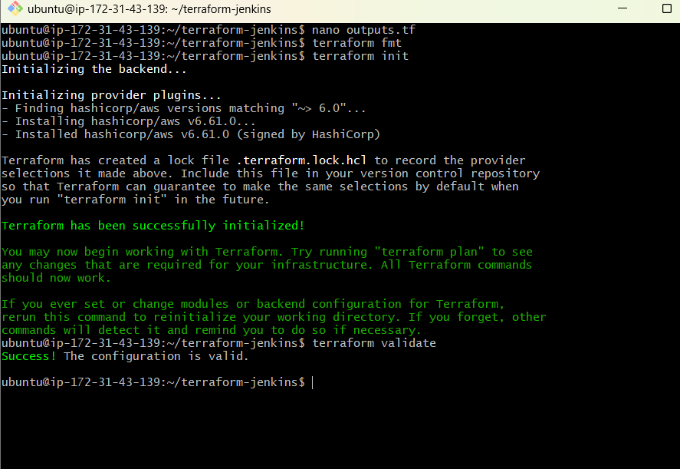
Step 10: Preview the infrastructure
terraform plan
Near the end, you should see:
Plan: 2 to add, 0 to change, 0 to destroy
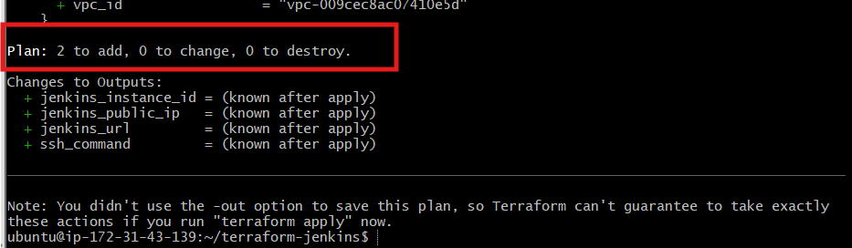
The two resources are:
- Jenkins security group
- Jenkins EC2 instance
Step 11: Create the infrastructure
terraform apply
Review the plan and enter:
yes
Expected:
Apply complete! Resources: 2 added, 0 changed, 0 destroyed.
Terraform will display:
jenkins_instance_id = "i-..."
jenkins_public_ip = "..."
jenkins_url = http://PUBLIC-IP:8080
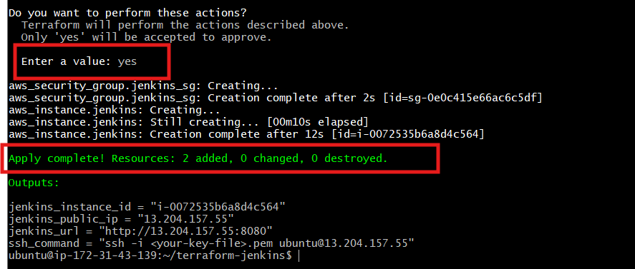
You can display these again using:
terraform output
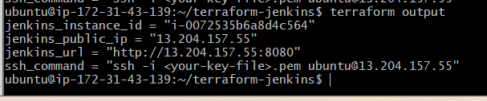
Step 12: Wait for Jenkins installation
The EC2 instance may be available before Jenkins finishes installing. Wait approximately 3–5 minutes, then test:
curl -I http://$(terraform output -raw jenkins_public_ip):8080
A response such as 403 Forbidden is acceptable because it proves Jenkins is running.
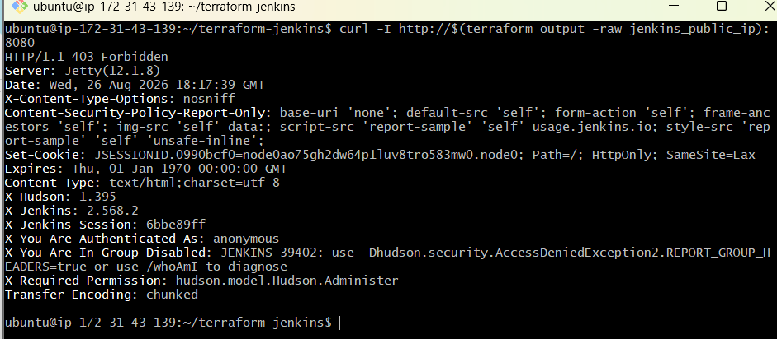
Step 13: Open Jenkins
Copy the URL:
terraform output -raw jenkins_url
Open it in your browser:
http://JENKINS-PUBLIC-IP:8080
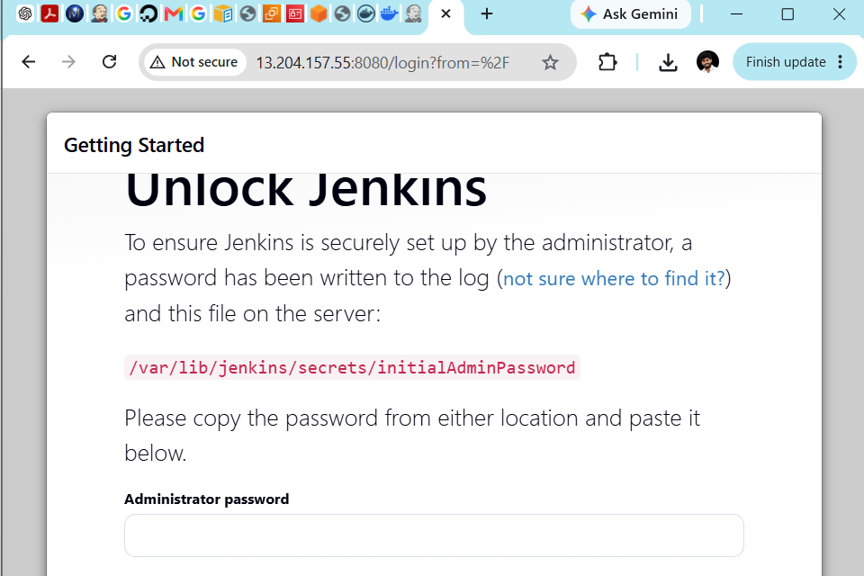
Step 14: Connect to the Jenkins EC2 using the new key
The key file is stored in the Downloads folder on your Windows computer.
First, exit from Docker-Practice-Server and return to Windows Git Bash:
kill %1 2>/dev/null
exit
Your prompt should look similar to:
kunch@hariprasad MINGW64 ~/Downloads
$
Go to Downloads:
cd ~/Downloads
Confirm the new key exists:
ls -l terraform-practice-key.pem
Set the correct permission:
chmod 400 terraform-practice-key.pem
Connect to the Jenkins EC2 instance:
ssh -i terraform-practice-key.pem ubuntu@ 13.204.157.55
If prompted:
Are you sure you want to continue connecting (yes/no/[fingerprint])?
Enter:
yes
After connecting, your prompt should change to the private IP address of the new Jenkins instance:
ubuntu@ip-172-31-x-x:~$
Step 15: Check the Jenkins service
sudo systemctl status jenkins
Expected:
Active: active (running)
Press q to exit the status screen.
Alternatively:
sudo systemctl is-active jenkins
Expected:
Active
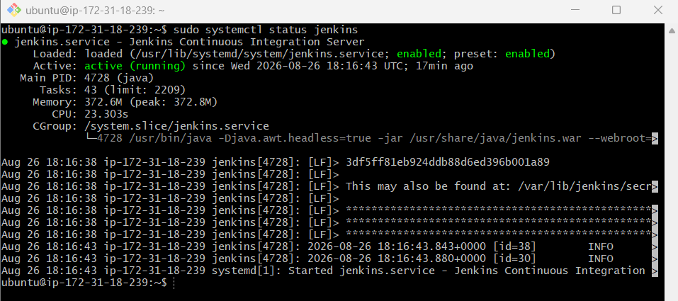
Step 16: Check the Docker service
sudo systemctl status docker
Expected:
Active: active (running)
Press q to exit.
Alternatively:
sudo systemctl is-active docker
Expected:
Active
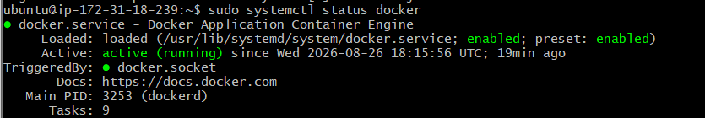
Step 17: Check Java
java -version
Expected:
openjdk version "21..."
Step 18: Get the initial Jenkins password
On the new Jenkins EC2 instance, run:
sudo cat /var/lib/jenkins/secrets/initialAdminPassword
A long password will be displayed. Copy it without additional spaces.
Do not share this password publicly.
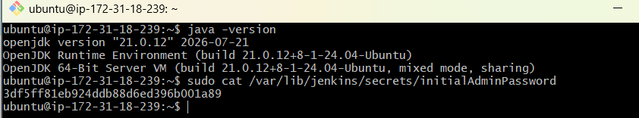
3df5ff81eb924ddb88d6ed396b001a89
Step 19: Unlock Jenkins
Open this URL:
http://13.204.157.55:8080
Paste the initial administrator password and click:
Continue
Step 20: Install Jenkins plugins
Choose:
Install suggested plugins
Wait for the plugin installation to finish.
Step 21: Create the Jenkins administrator account
Example:
Username: jenkinsadmin
Password: A strong password
Full name: Jenkins Admin
Email: your email address
Click:
Save and Continue
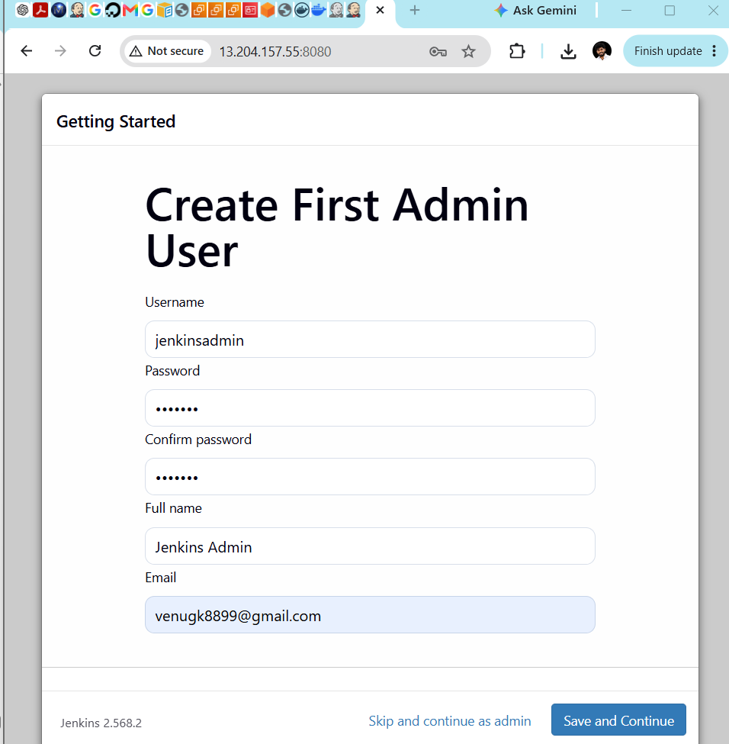
Confirm the Jenkins URL:
http://13.204.157.55:8080/
Then click:
Save and Finish
Finally:
Start using Jenkins
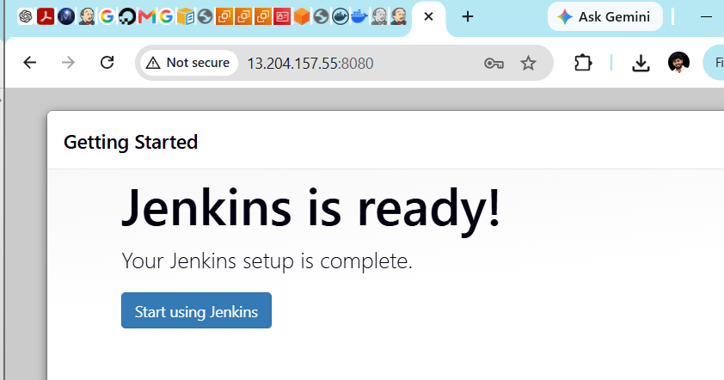
Step 22: Verify that Jenkins can use Docker
From the Jenkins EC2 terminal:
sudo -u jenkins docker ps
Expected:
CONTAINER ID IMAGE COMMAND CREATED STATUS PORTS NAMES
An empty list is okay.
Step 23: Verify Terraform outputs
Terraform commands must be run on Docker-Practice-Server, where the Terraform configuration and state are stored—not on the new Jenkins server.
leave the Jenkins EC2 instance:
exit
You should return to Windows Git Bash.
Connect to Docker-Practice-Server:
cd ~/Downloads
ssh -i docker-practice-key.pem ubuntu@13.206.189.74
Then run:
cd ~/terraform-jenkins
terraform output
Expected output will resemble:
jenkins_instance_id = "i-xxxxxxxxxxxxxxxxx"
jenkins_public_ip = "13.204.15.75"
jenkins_url = "http://13.204.15.75:8080"
ssh_command = "ssh -i terraform-practice-key.pem ubuntu@13.204.15.75"
This confirms Terraform is tracking the Jenkins resources correctly.
Do not run:
terraform destroy
After checking terraform output
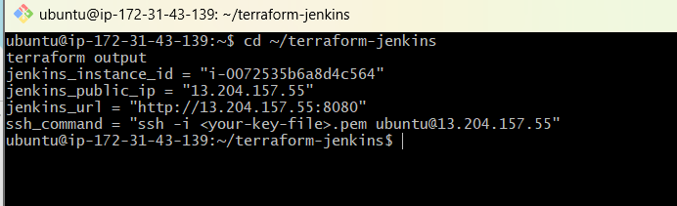

Task 5: Jenkins pipeline to build and push Docker image
The pipeline will:
- Clone https://github.com/betawins/Python-app.git
- Build the Docker image
- Tag it with the Jenkins build number
- Push it to Docker Hub
- Push/update the latest tag
Docker Hub image:
venudocker8899/python-app
Step 1: Verify tools on the Jenkins server
Connect from Windows Git Bash:
cd ~/Downloads
ssh -i terraform-practice-key.pem ubuntu@13.204.15.75
Run:
git --version
docker --version
java -version
Verify Jenkins has Docker permission:
sudo -u jenkins docker ps
Expected:
CONTAINER ID IMAGE COMMAND CREATED STATUS PORTS NAMES
An empty result is correct.
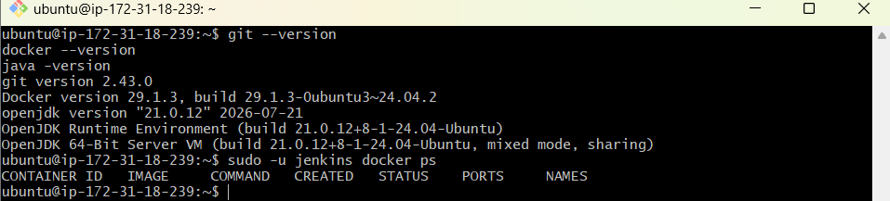
Step 2: Verify required Jenkins plugins
Open Jenkins:
http://13.204.157.55:8080
Navigate to:
Manage Jenkins
→ Plugins
→ Installed plugins
Search and confirm these plugins are installed:
Pipeline
Git
Credentials Binding
The Docker Pipeline plugin is not mandatory because we’ll use standard docker shell commands.
If any plugin is missing:
Available plugins
→ Search plugin name
→ Select plugin
→ Install
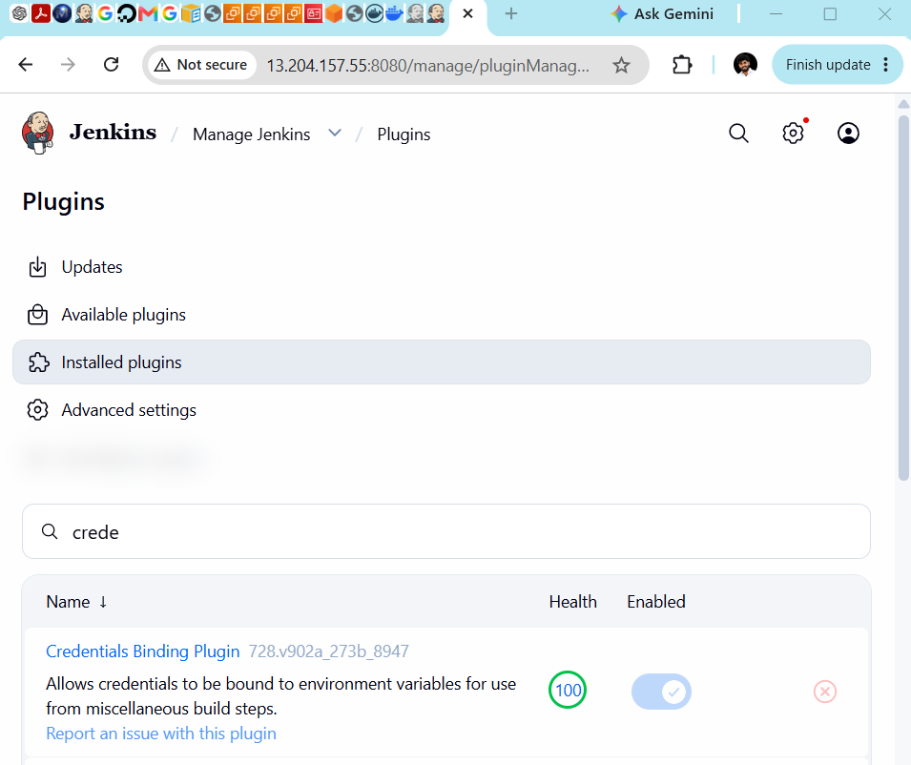
Step 3: Create the Docker Hub credential
Navigate to:
Manage Jenkins
→ Credentials
→ System
→ Global credentials (unrestricted)
→ Add Credentials
Enter:
Field | Value
Kind | Username with password
Scope | Global
Username | venudocker8899
Password | Docker Hub personal access token
ID | dockerhub-credentials
Description | Docker Hub Credentials
Important: enter your Docker Hub access token in the Password field, not your Docker Hub account password.
Click:
Create
Confirm that the credential ID appears as:
dockerhub-credentials
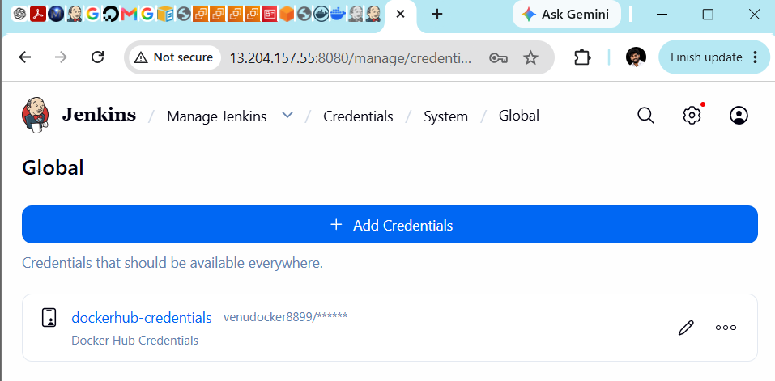
Step 4: Create the Jenkins pipeline job
1. Create a new job
From the Jenkins dashboard, click:
New Item
Enter:
Job name: Python-App-Docker-Pipeline
Select:
Pipeline
Click:
OK
2. Configure the pipeline
Scroll to the Pipeline section.
Select:
Definition: Pipeline script
Paste this script:
pipeline {
agent any

environment {
IMAGE_NAME = 'venudocker8899/python-app'
}

stages {
stage('Checkout') {
steps {
git branch: 'main',
url: 'https://github.com/betawins/Python-app.git'
}
}

stage('Prepare Dockerfile') {
steps {
writeFile file: 'Dockerfile', text: '''
FROM python:3.12-slim

WORKDIR /app

COPY requirements.txt .

RUN pip install --no-cache-dir -r requirements.txt

COPY . .

EXPOSE 8080

CMD ["python", "app.py"]
'''
}
}

stage('Build Docker Image') {
steps {
sh '''
docker build \
-t ${IMAGE_NAME}:${BUILD_NUMBER} \
-t ${IMAGE_NAME}:latest .
'''
}
}

stage('Docker Hub Login') {
steps {
withCredentials([
usernamePassword(
credentialsId: 'dockerhub-credentials',
usernameVariable: 'DOCKERHUB_USER',
passwordVariable: 'DOCKERHUB_TOKEN'
)
]) {
sh '''
echo "$DOCKERHUB_TOKEN" | \
docker login \
-u "$DOCKERHUB_USER" \
--password-stdin
'''
}
}
}

stage('Push to Docker Hub') {
steps {
sh '''
docker push ${IMAGE_NAME}:${BUILD_NUMBER}
docker push ${IMAGE_NAME}:latest
'''
}
}
}

post {
success {
echo 'Docker image built and pushed successfully.'
}

failure {
echo 'Pipeline failed. Check the console output.'
}

always {
sh 'docker logout || true'
}
}
}
3. Check important values
Before saving, confirm:
IMAGE_NAME = 'venudocker8899/python-app'
credentialsId: 'dockerhub-credentials'
git branch: 'main'
These values must match exactly.
4. Save the job
Click:
Save
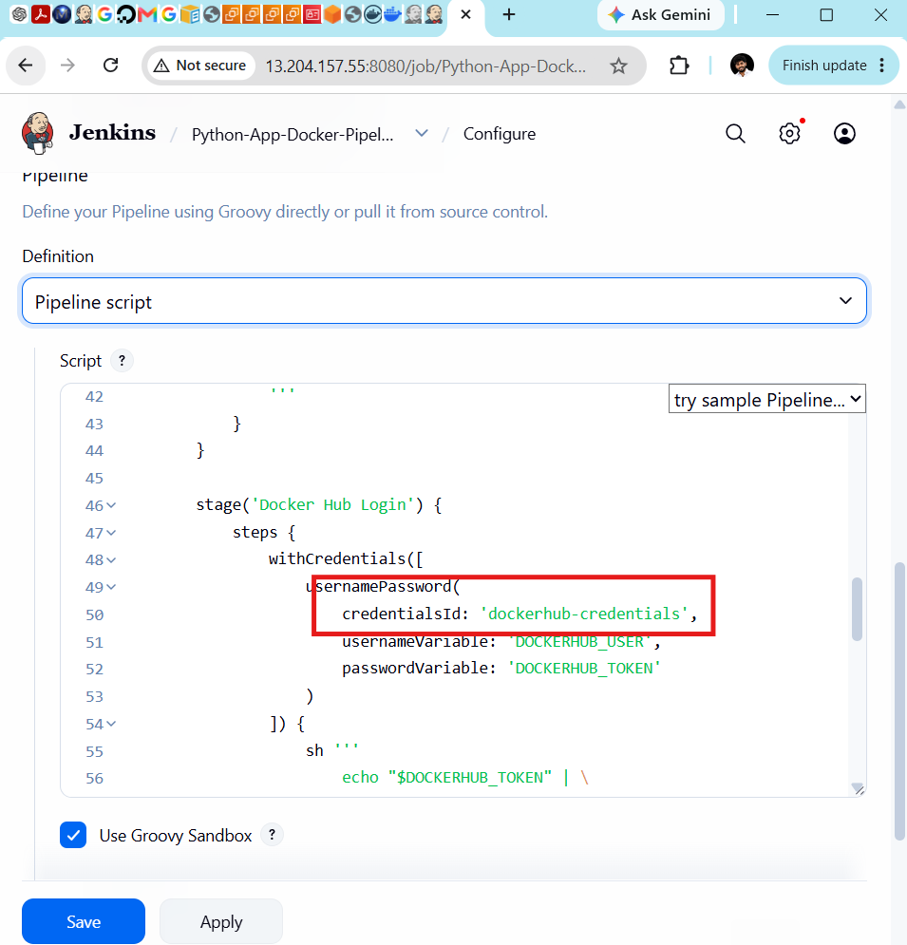
5. Start the pipeline
Click:
Build Now
A build should appear under Build History, such as:
#1
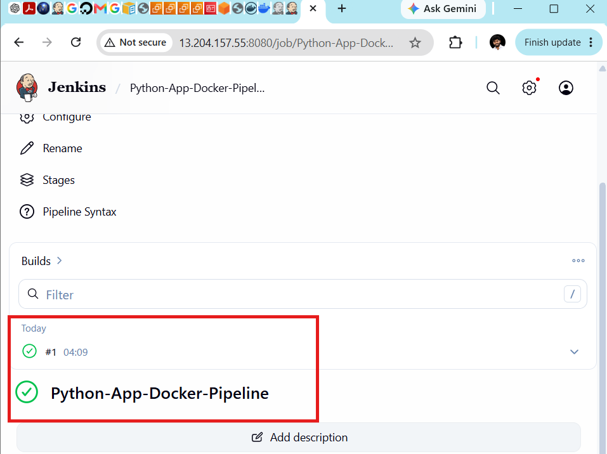
Click:
#1 → Console Output
The expected stages are:
Checkout
Prepare Dockerfile
Build Docker Image
Docker Hub Login
Push to Docker Hub
At the end, you should see:
Finished: SUCCESS
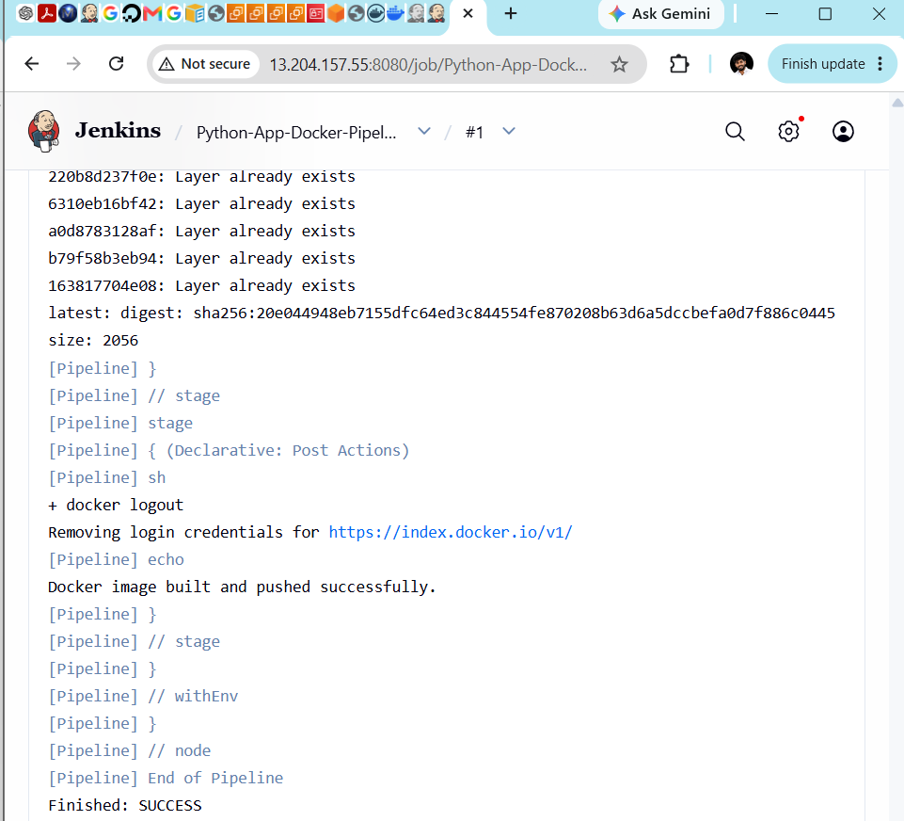

The Jenkins pipeline completed:
- Source cloned from GitHub
- Modern Dockerfile prepared
- Docker image built
- Build-number tag pushed
- latest tag pushed to Docker Hub
Final verification
Open your Docker Hub repository:
venudocker8899/python-app
Under Tags, confirm:
latest
1
If your successful Jenkins build number was different, you will see that number instead of 1.
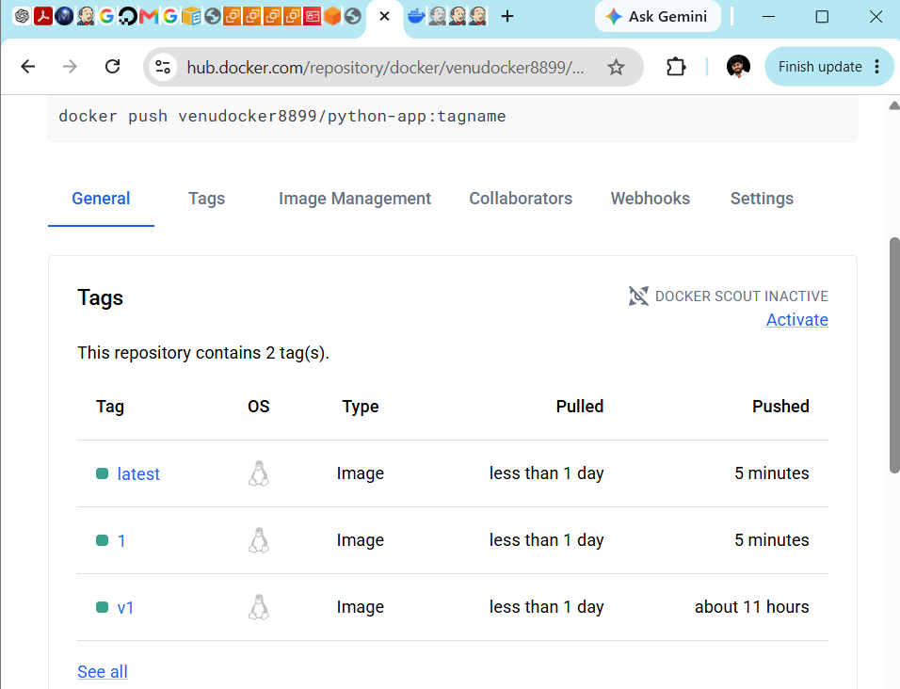
On the Jenkins server, verify:
sudo -u jenkins docker images venudocker8899/python-app
Expected:
venudocker8899/python-app latest
venudocker8899/python-app 1
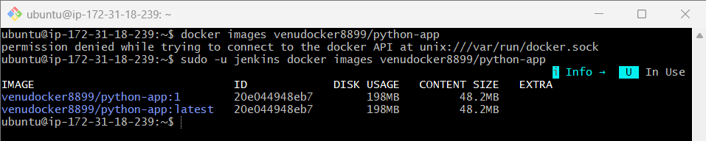
You can also test the Jenkins-built image locally:
docker run -d \
--name jenkins-python-test \
-p 8085:8080 \
venudocker8899/python-app:latest
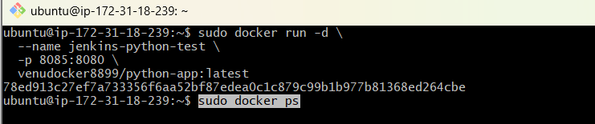
Test:
curl http://localhost:8085
After testing, remove only the test container:
docker rm -f jenkins-python-test
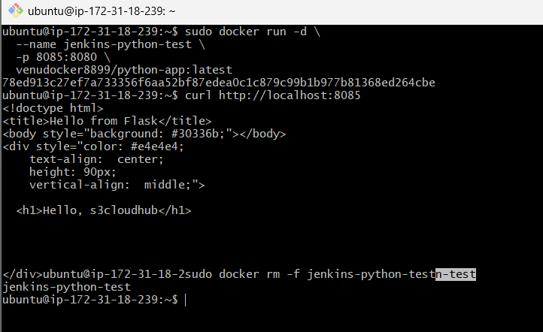

Frontend Docker Image
Perform this task on your existing Docker-Practice-Server, not the Jenkins server.
Step 1: Return to Windows and connect to Docker-Practice-Server
Exit the Jenkins server:
exit
From Windows Git Bash:
cd ~/Downloads
ssh -i docker-practice-key.pem ubuntu@13.206.189.74
Step 2: Clone the source-code repository
cd ~
git clone https://github.com/betawins/docker-tasks.git
If it says the directory already exists:
cd ~/docker-tasks
git pull
Enter the frontend directory:
cd ~/docker-tasks/Frontend_based_source
Check the files:
ls -l
Expected:
index.html
javascript.js
style.css
todayDeal.js
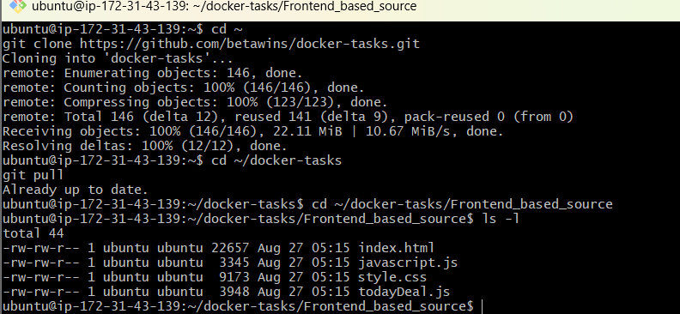
Step 3: Create the frontend Dockerfile
nano Dockerfile
Add:
FROM nginx:alpine

RUN rm -rf /usr/share/nginx/html/*

COPY . /usr/share/nginx/html/

EXPOSE 80

CMD ["nginx", "-g", "daemon off;"]
Save:
Ctrl+O
Enter
Ctrl+X
Step 4: Build the image
docker build -t venudocker8899/frontend-app:v1 .
Verify:
docker images venudocker8899/frontend-app
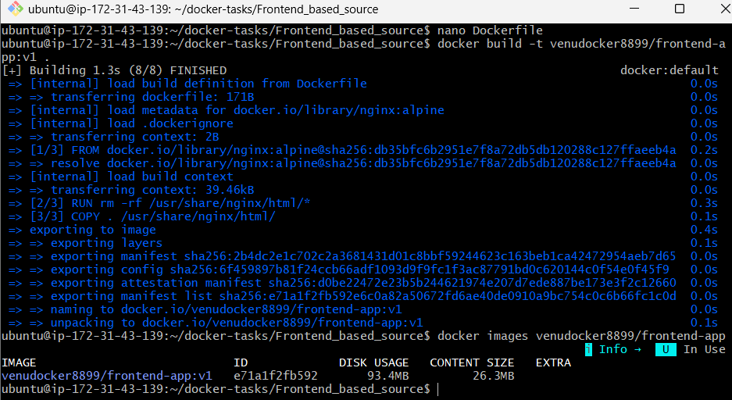
Step 5: Run the container
Use port 8086 to avoid conflicts:
docker run -d \
--name frontend-app-container \
-p 8086:80 \
venudocker8899/frontend-app:v1
Check:
docker ps
Test:
curl -I http://localhost:8086
Expected:
HTTP/1.1 200 OK
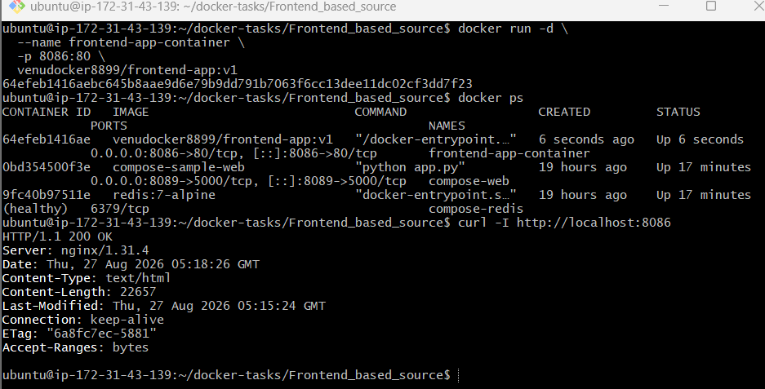
Step 6: View the application
To open the application from your browser, add a security-group inbound rule:
Type | Port | Source
Custom TCP | 8086 | My IP or 0.0.0.0/0 temporarily
Open:
http://13.206.189.74:8086
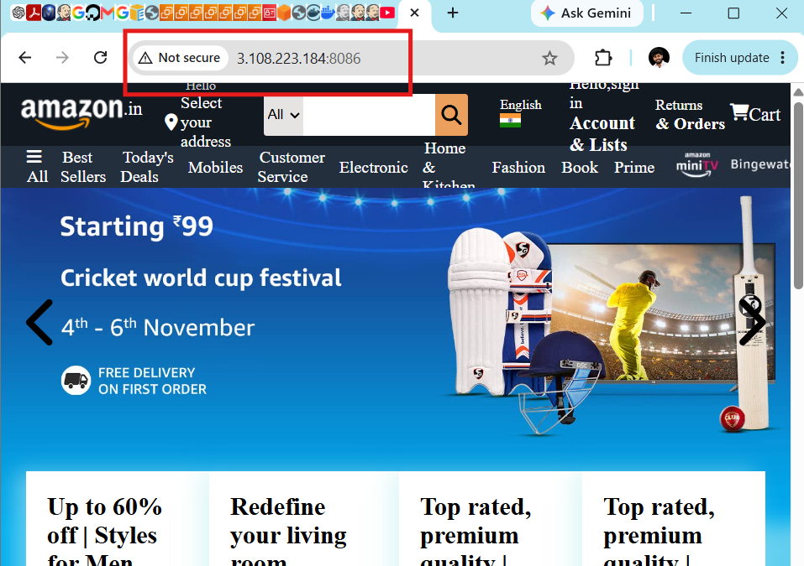
Step 7: Push to Docker Hub
Create a Docker Hub repository named:
frontend-app
Log in if necessary:
docker login -u venudocker8899
Push:
docker push venudocker8899/frontend-app:v1
Verify the v1 tag on Docker Hub.
Complete through the local curl test first. If the frontend returns 200 OK, continue with the Docker Hub push.
The screenshot confirms:
Login Succeeded
v1: digest: sha256:...
Image pushed successfully:
venudocker8899/frontend-app:v1
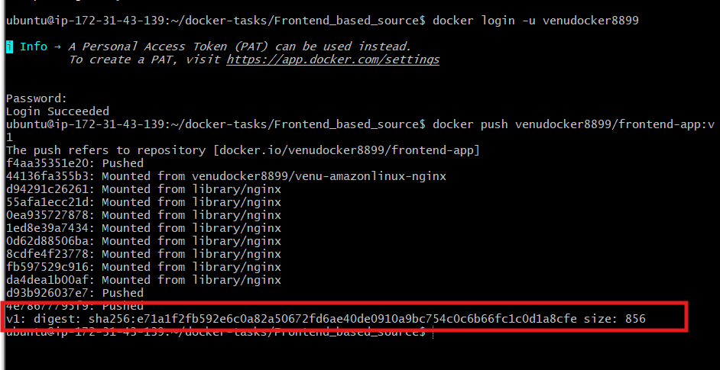

Java-based Docker image
Continue on Docker-Practice-Server.
Step 1: Enter the Java source directory
cd ~/docker-tasks/Java_based_source
Check the files:
ls -l
Expected:
pom.xml
src
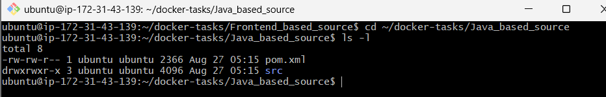
Step 2: Create a multi-stage Dockerfile
nano Dockerfile
Add:
# Build stage
FROM maven:3.9-eclipse-temurin-11 AS builder

WORKDIR /app

COPY pom.xml .

RUN mvn dependency:go-offline

COPY src ./src

RUN mvn clean package -DskipTests

# Runtime stage
FROM eclipse-temurin:11-jre

WORKDIR /app

COPY --from=builder /app/target/spring-boot-web.jar app.jar

EXPOSE 8080

CMD ["java", "-jar", "app.jar"]
Save:
Ctrl+O
Enter
Ctrl+X
Step 3: Build the Java image
docker build -t venudocker8899/java-app:v1 .
The first Maven build can take several minutes because it downloads dependencies.
Verify:
docker images venudocker8899/java-app
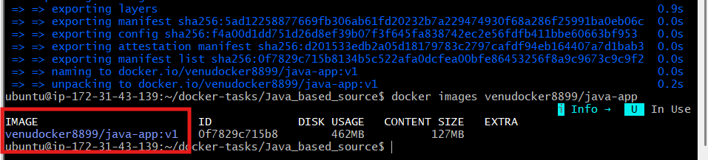
Step 4: Run the Java container
docker run -d \
--name java-app-container \
-p 8087:8080 \
venudocker8899/java-app:v1
Check:
docker ps
Watch the Spring Boot logs:
docker logs -f java-app-container
Wait until you see a message similar to:
Started StartApplication
Press:
Ctrl+C
This stops log viewing only; it does not stop the container.
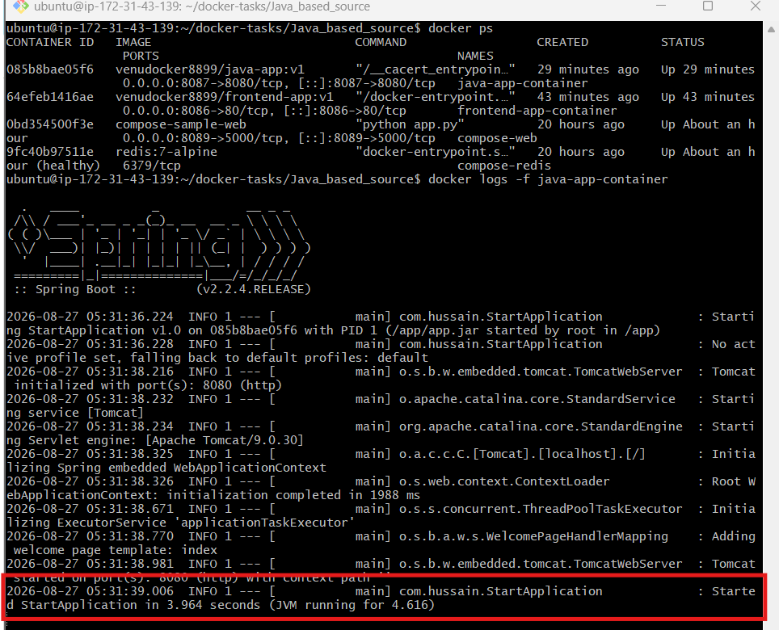
Step 5: Test the application
curl -I http://localhost:8087
Expected:
HTTP/1.1 200
If the container exits, check:
docker ps -a
docker logs java-app-container
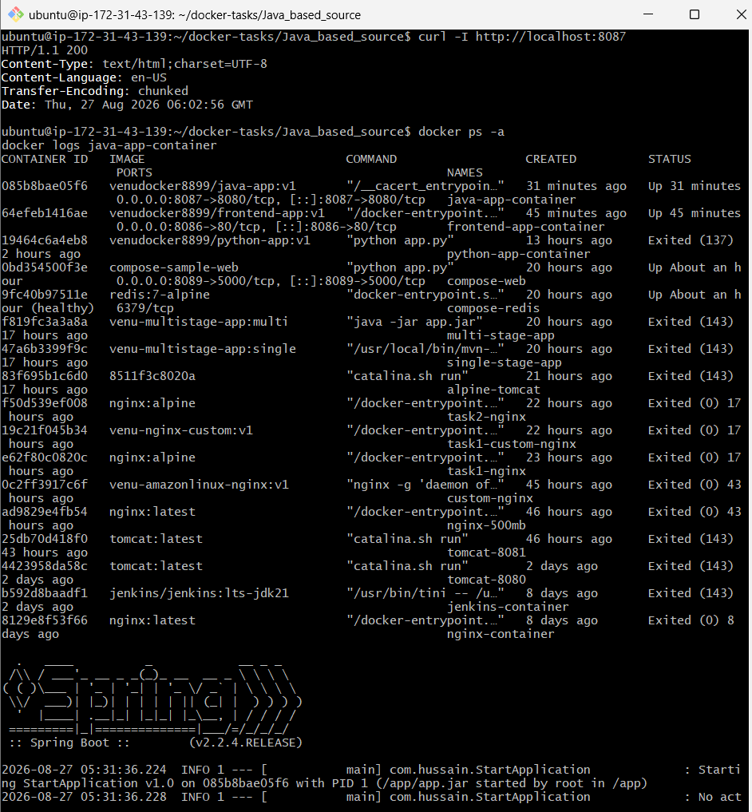
Step 6: Push to Docker Hub
Create a public Docker Hub repository named:
java-app
Push the image:
docker push venudocker8899/java-app:v1
Successful output ends with:
v1: digest: sha256:...
Then verify the v1 tag in Docker Hub.
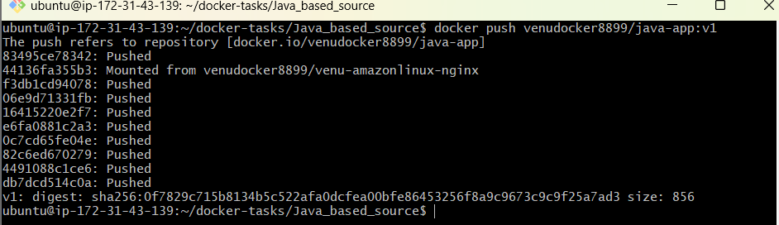
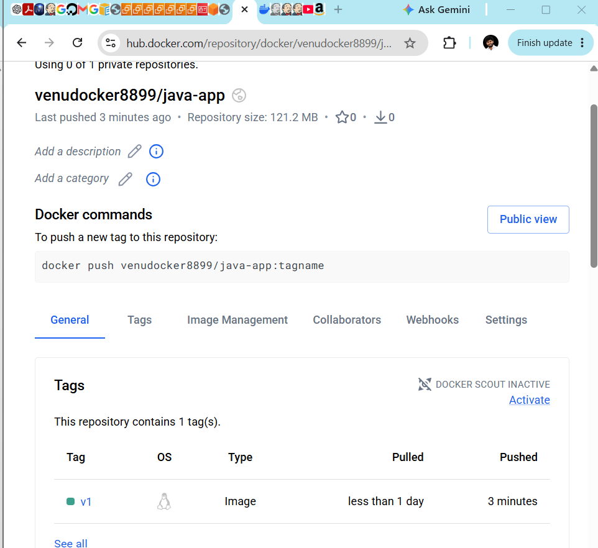

Node.js Docker Image with Tag v1
Continue on Docker-Practice-Server.
Step 1: Enter the Node.js source directory
cd ~/docker-tasks/NodeJs_based_source
Check:
ls -l
Expected:
package.json
package-lock.json
public
src
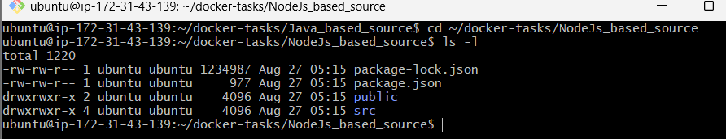
Step 2: Create a multi-stage Dockerfile
nano Dockerfile
Add:
# Build stage
FROM node:18-alpine AS builder

WORKDIR /app

COPY package*.json ./

RUN npm ci

COPY . .

RUN npm run build

# Runtime stage
FROM nginx:alpine

RUN rm -rf /usr/share/nginx/html/*

COPY --from=builder /app/build /usr/share/nginx/html

EXPOSE 80

CMD ["nginx", "-g", "daemon off;"]
Save:
Ctrl+O
Enter
Ctrl+X
Step 3: Create .dockerignore
nano .dockerignore
Add:
node_modules
build
npm-debug.log
.git
Dockerfile
Save and exit.
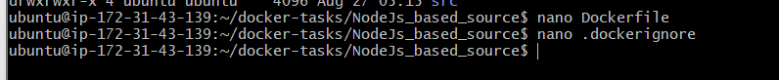
Step 4: Build with tag v1
docker build -t venudocker8899/nodejs-app:v1 .
The first build may take several minutes because npm ci downloads the dependencies.
Verify:
docker images venudocker8899/nodejs-app
Expected:
venudocker8899/nodejs-app v1
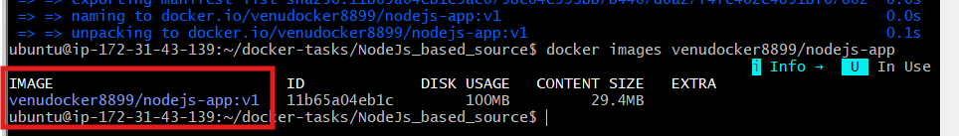
Step 5: Run the container
docker run -d \
--name nodejs-app-container \
-p 8088:80 \
venudocker8899/nodejs-app:v1
Check:
docker ps
Test:
curl -I http://localhost:8088
Expected:
HTTP/1.1 200 OK
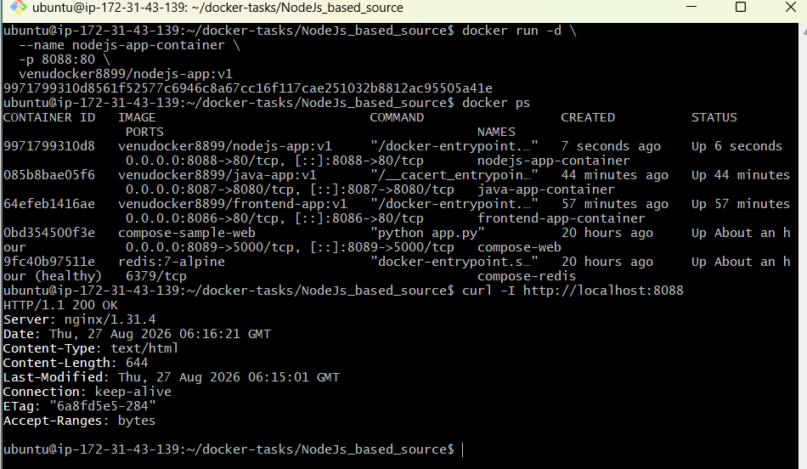

Step 6: Open it in a browser
If you want browser access, temporarily allow port 8088 in the Docker-Practice-Server security group.
Open:
http://13.206.189.74:8088
You should see the React-based Zomato clone.
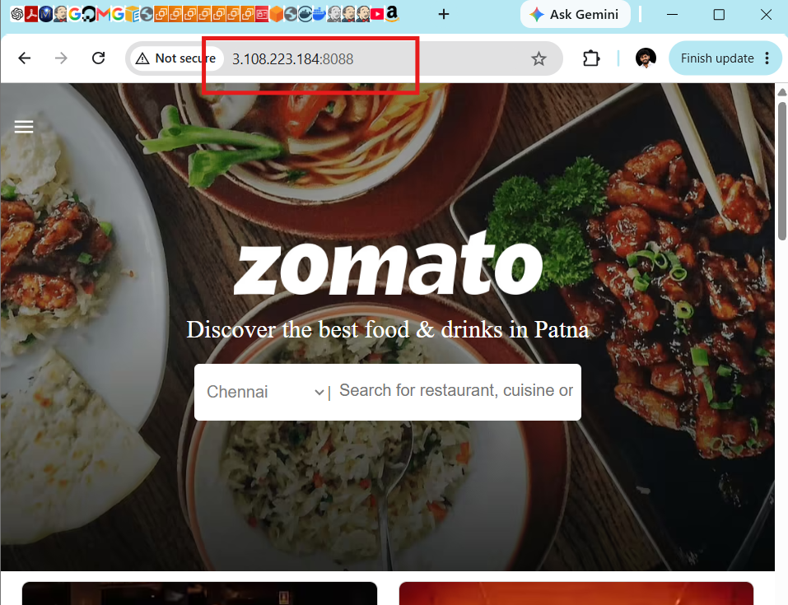
Step 7: Push to Docker Hub
docker push venudocker8899/nodejs-app:v1
Successful output ends with:
v1: digest: sha256:...
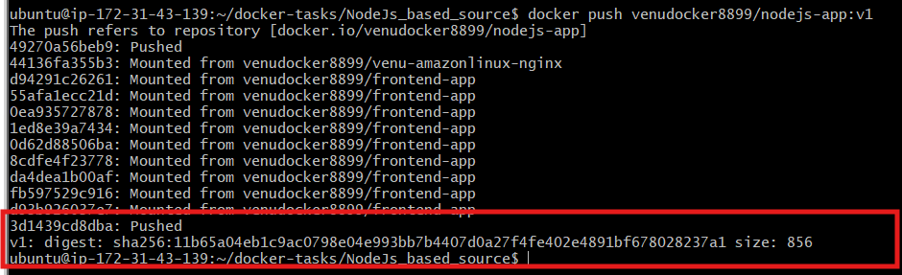
Then verify:
Docker Hub → Repositories → nodejs-app → Tags → v1
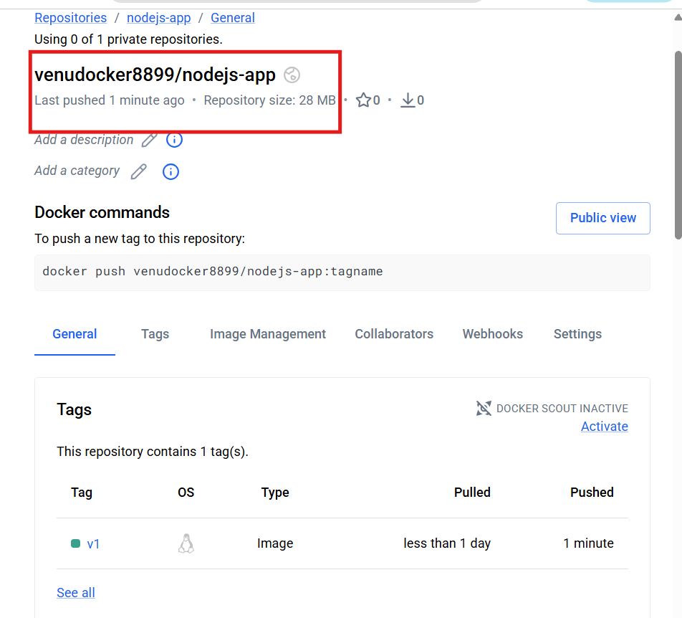

Docker Task: WordPress with MySQL using Docker Compose
Complete this on Docker-Practice-Server.
Step 1: Verify Docker Compose
docker compose version
Expected:
Docker Compose version v2...
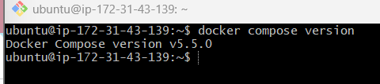
Step 2: Create the project directory
cd ~
mkdir wordpress-compose
cd wordpress-compose
Step 3: Create the environment file
nano .env
Add:
MYSQL_ROOT_PASSWORD=RootPass8899
MYSQL_DATABASE=wordpressdb
MYSQL_USER=wordpressuser
MYSQL_PASSWORD=WordPressPass8899
These are lab passwords. Use stronger secret values for a real environment.
Save:
Ctrl+O
Enter
Ctrl+X
Protect the file:
chmod 600 .env
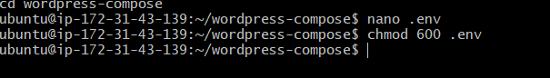
Step 4: Create docker-compose.yml
nano docker-compose.yml
Add:
services:
mysql:
image: mysql:8.0
container_name: wordpress-mysql
restart: unless-stopped
environment:
MYSQL_ROOT_PASSWORD: ${MYSQL_ROOT_PASSWORD}
MYSQL_DATABASE: ${MYSQL_DATABASE}
MYSQL_USER: ${MYSQL_USER}
MYSQL_PASSWORD: ${MYSQL_PASSWORD}
volumes:
- mysql_data:/var/lib/mysql
healthcheck:
test:
- CMD-SHELL
- mysqladmin ping -h localhost -u root -p$${MYSQL_ROOT_PASSWORD}
interval: 10s
timeout: 5s
retries: 10

wordpress:
image: wordpress:latest
container_name: wordpress-app
restart: unless-stopped
depends_on:
mysql:
condition: service_healthy
ports:
- "8089:80"
environment:
WORDPRESS_DB_HOST: mysql:3306
WORDPRESS_DB_NAME: ${MYSQL_DATABASE}
WORDPRESS_DB_USER: ${MYSQL_USER}
WORDPRESS_DB_PASSWORD: ${MYSQL_PASSWORD}
volumes:
- wordpress_data:/var/www/html

volumes:
mysql_data:
wordpress_data:
Save and exit.
Step 5: Validate the Compose file
docker compose config
It should display the resolved configuration without an error.
Important: this output contains the resolved database passwords, so don’t share its full output publicly.
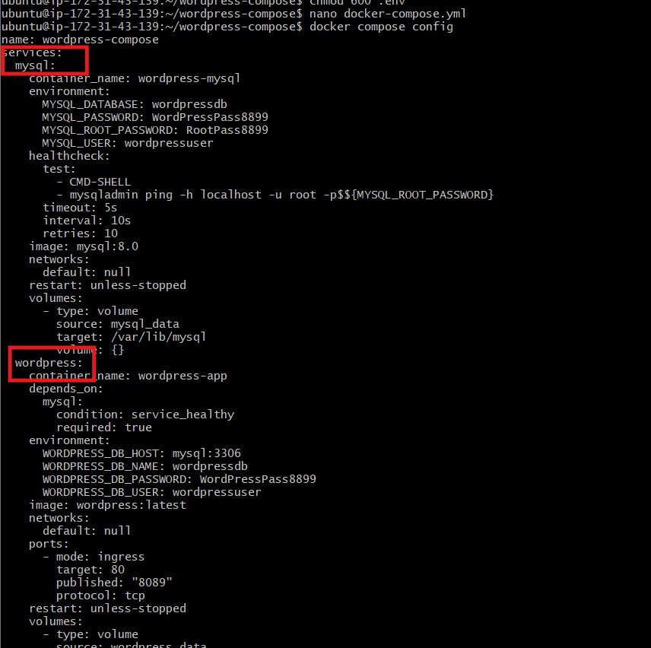
Step 6: Start WordPress and MySQL
docker compose up -d
Check:
docker compose ps
Expected:
wordpress-mysql Up (healthy)
wordpress-app Up
MySQL may take approximately 30–60 seconds to become healthy.
Check again if WordPress is still waiting:
docker compose ps
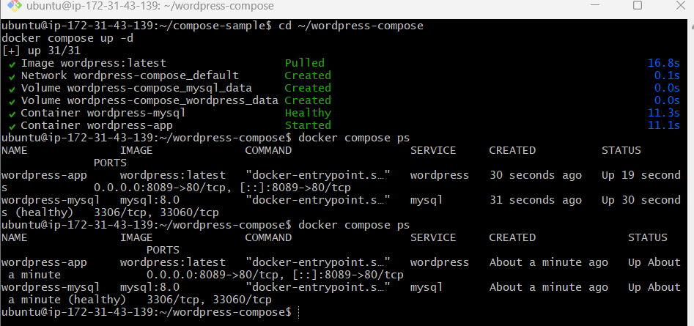
Step 7: Test locally
curl -I http://localhost:8089
A 200 OK or 302 Found response is correct.
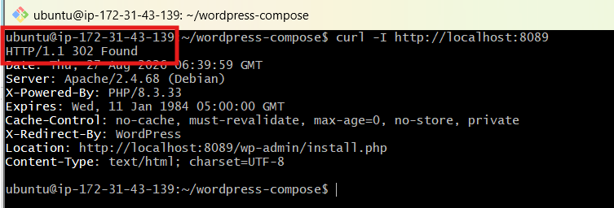
Step 8: Open WordPress
Add this inbound rule to the Docker-Practice-Server security group:
Type | Port | Source
Custom TCP | 8089 | My IP or 0.0.0.0/0 temporarily
Open:
http://3.108.223.184:8089
You should see the WordPress installation page.
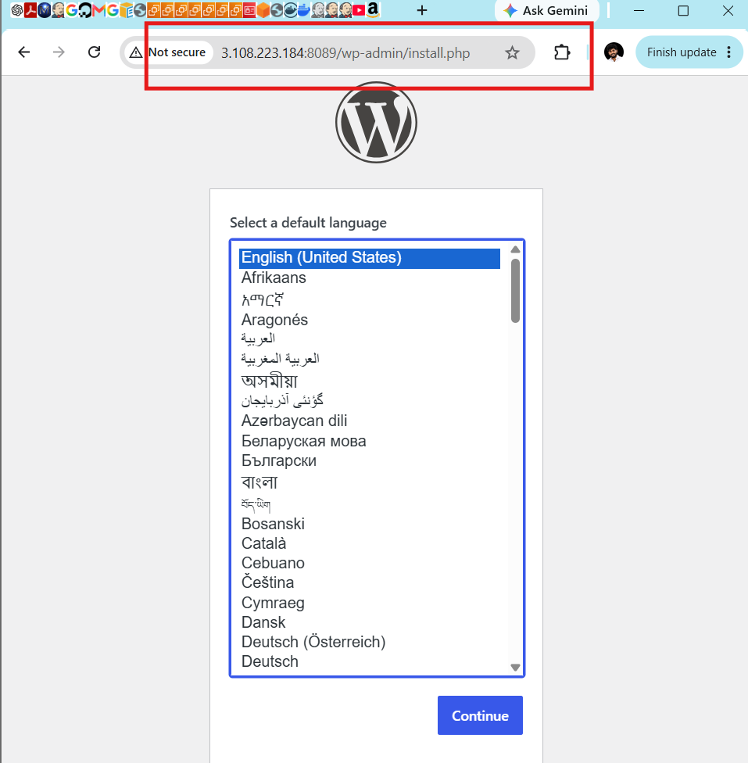
Select the language and create:
- Site title
- WordPress administrator username
- Strong administrator password
- Email address
These WordPress administrator details are different from the MySQL credentials.
